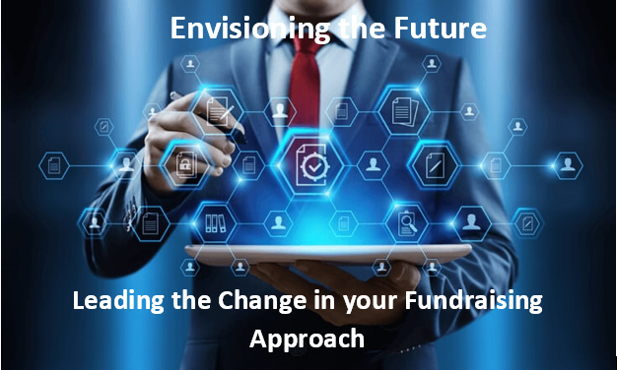

8:00 am – 8:45 am | Pre-Conference Networking Opportunities (Conference Log-In)
8:45 am – 9:05 am | Welcome and Conference Kick-Off
9:05 am – 10:05 am | I Don’t Know What I Don’t Know: Improving Fundraiser Relations Through Needs Assessment  Rachael Walker, Director of Research & Reporting, Western Carolina University
 | One prospect researcher in a large development office thought she was just working on an independent study for her MLIS. What she was actually doing was repairing long-damaged relationships between prospect research and frontline fundraisers. In this case study of a needs assessment process, find out what she learned about what works, what doesn’t, and what a big difference listening can make.
10:05 am – 10:15 am | Break
10:15 am – 11:15 am | SESSION 2:  Evolution of a Principal Gifts Program: Goals, Ongoing Evaluation and Collaboration  Jada Garrison, Former Executive Director of Prospect Research, Management & Analysis, The University of Texas at Austin  Karina Garcia, Research Analyst, The University of Texas at Austin
 | Major and principal gift fundraising is at the heart of operations for most nonprofit programs. However, not each prospect type should be managed the same. In this session we will uncover how The University of Texas at Austin defines Principal Gifts-level prospects and the process it has developed to prioritize and track their movement through the fundraising cycle.
11:15 pm -11:45 pm | (Sponsorship Sessions) iWave
11:45 pm – 1:00 pm | Break/Lunch
1:00 pm – 2:00 pm | SESSION 3:  What Fundraisers Need to Know to Maximize Gifts  Christy Butler Eckoff, J.D., LL.M., CAP, Chief Foundation Officer at Atlanta Jewish Foundation
 | Did you know that 80% of gifts come from a person’s income but 80% of someone’s wealth is usually in their assets? Gifts from assets and other planned gifts can be 200 times an annual gift. How can we give development officers the tools to identify these assets and donors who can make these types of gifts. We will examine different types of assets that make impactful gifts, how the new tax laws may impact these gifts, and other “planned gifts” What types of information do development officers need to know to start conversations with donors? How can we identify these prospects and maximize a donor’s philanthropy?
2:00 pm – 2:15 pm | Break
2:15 pm – 3:15 pm | SESSION 4:  Demystifying DEI in Prospect Development  Chandra Montgomery, Executive Consultant at Lindauer Global
 | The imperative to build greater diversity, equity, and inclusion (DEI) within our organizations has real implications for the practice of prospect development. While we may be clear on the "why" of embedding DEI principles in our work, many of us may be challenged by the "what" and the "how." In this interactive session, we will think about the framework to develop strategies and tactics that leverage core prospect development competencies to advance equity and inclusion. Participants will explore concrete examples and problem-solve to develop strategies that propel our organizations to maximize engagement and philanthropic opportunities
3:15 pm – 3:30 pm | APRA Florida Updates/Closing Remarks
3:30 pm – 4:30 pm | Networking
*Schedule is subject to change

